Global World War II Symposium
Saturday, July 16
Fitzwilliam, College, Cambridge.

11:00-11:15 Welcome and Introductions [Wilson Court]

11:15-12:00 Ruth Lawlor: “The Global World War II: Issues and Perspectives” [Wilson Court, Fitzwilliam College]

12:00 -13:00 Lunch [Auditorium Foyer, Gatehouse Court]

13:00-15:30 Discussion on “The Global World War II: Issues and Perspectives” [Wilson Court]

15:30-16:00 Refreshments [Auditorium Foyer, Gatehouse Court]

16:00-18:00 Globalizing World War II: Where to from Here?

Round table with Andy Buchanan (Global World War II Project); Laure Humbert (Colonial and Transnational Intimacies: Medical Humanitarianism in the French external resistance, 1940-1945); Catriona Pennell (Marginalised Histories of World War II); Jonathan Fennell (Second World War Research Group).

19:00 pm Pub dinner at the Fort St. George, Midsummer Common, Cambridge CB4 1HA.

Walking: Distance 1 mile –15-20 minutes.

Bus: Take the No. 5 bus from Fitzwilliam College, ride 3 stops (Shire Hall, Bridge Street, Belmont Place), walk 10 minutes to pub.

Point of contact:

Ruth Lawlor, University of Cambridge

Email: rgl34@cam.ac.uk
Tel.: +44 7401 126157

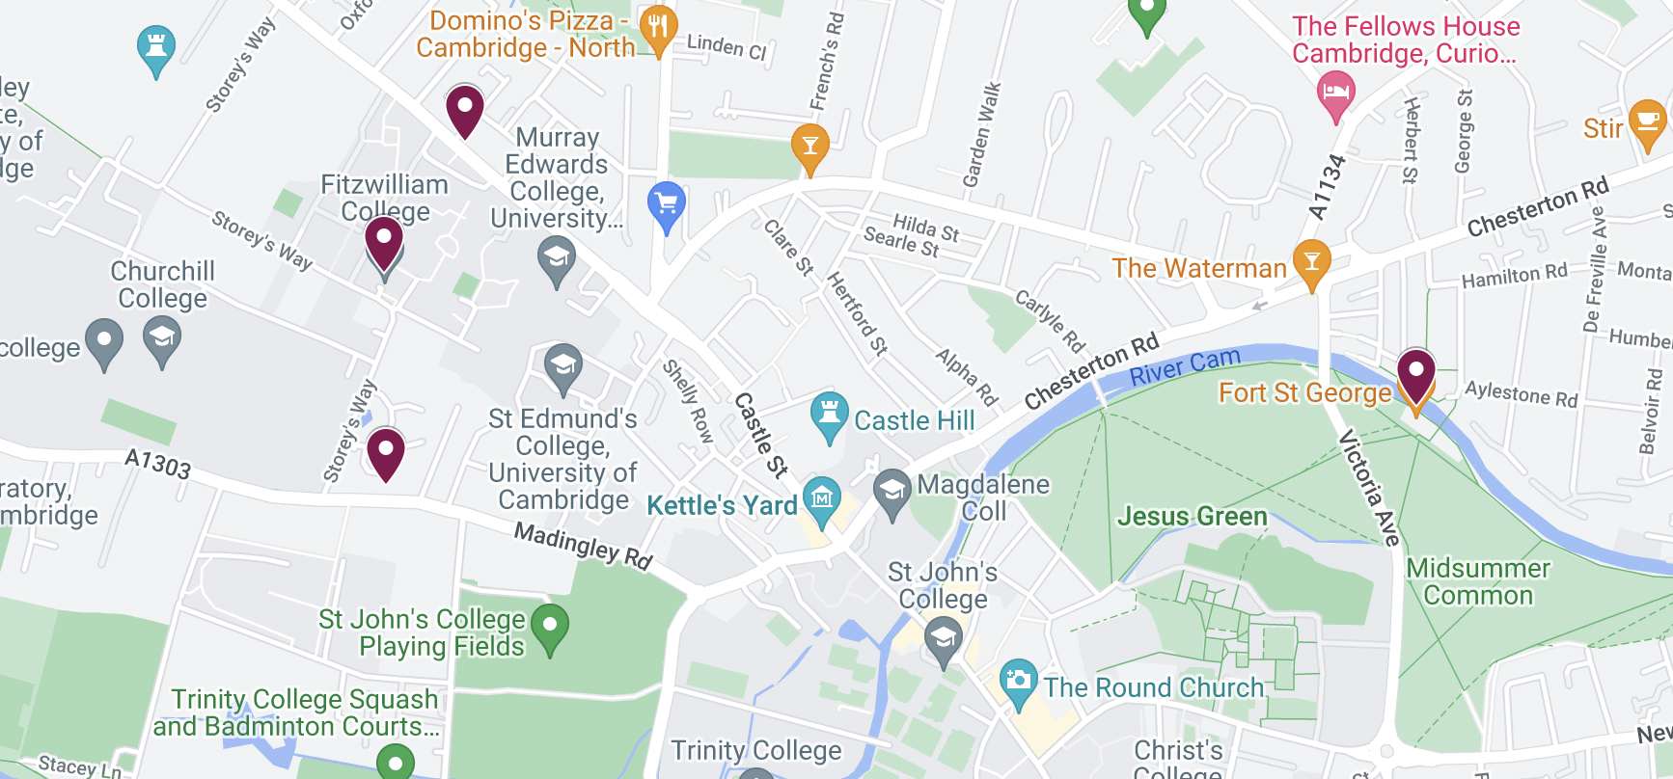

Map:
Fitzwilliam College to Midsummer Common with locations, including bus stops, marked in purple

