International conference:
HISTORIE(S) OF CARE
Gender, Experiences and Humanitarian Knowledge(s)

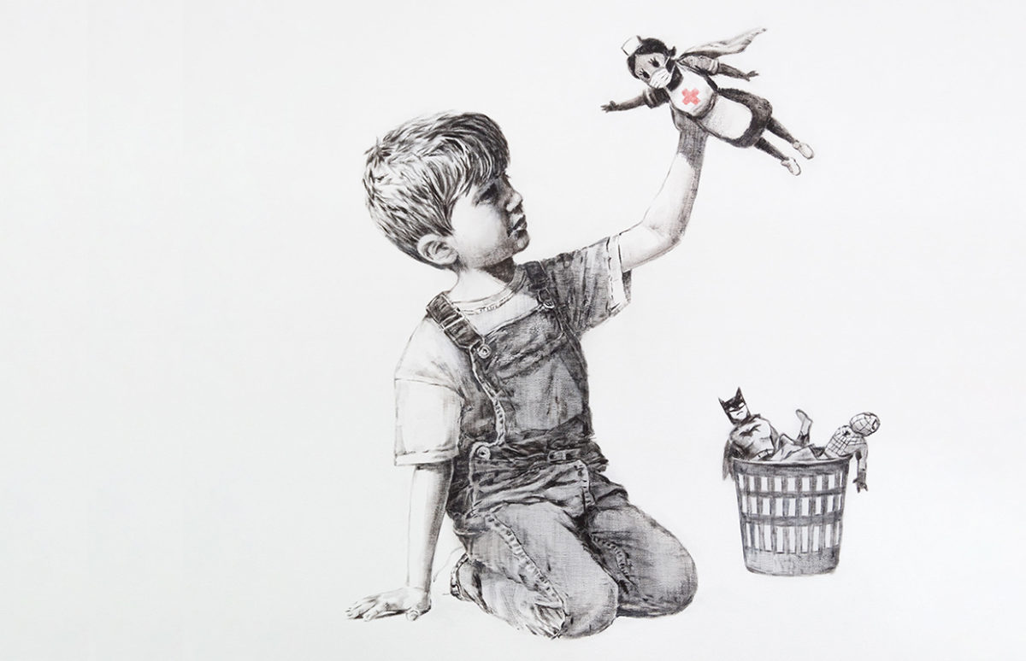

Bansksy, Game Changer, 2020.

Brocher Foundation, (Hermance, Switzerland)
16th September, 2022


Program
09.15 Introduction. Towards a history of care
Dolores Martín-Moruno, Brenda Lynn Edgar (iEH2, University of Geneva) and Valérie Gorin (Geneva Centre for Humanitarian Studies)

09.45 Care as a gendered quest within humanitarian history
Chair: Nicole C. Bourbonnais (Geneva Graduate Institute)

Transnational humanitarian experiences and political commitments: the case of the Belgian nurse Madame Perdomo, Alejandra de Leiva and Jon Arrizabalaga (Institución Milà i Fontanals, Barcelona)

Caring for the world: geography, cosmology and encounters, a woman ‘actionist’ career, 1943-1990, Bertrand Taithe (University of Manchester)

‘Why I stand in solidarity’: Pia Klemp’s rescue missions in the Mediterranean, Dolores Martín-Moruno (iEH2, University of Geneva)

11:15 Coffee break

11.30 Institutionalising care in humanitarian practices
Chair: Brenda Lynn Edgar (iEH2, University of Geneva)

Writing as a form of care: The correspondence of wartime godmothers and Belgian soldiers during the First World War on the Yser front, Marie Leyder (Max Planck Institute for Human Development, Centre for the History of Emotions)

Visual strategies for ongoing care. Appealing to American donors to support Belgian lacemakers after the First World War, Claire Barber, Rebecca Gill and Wendy Wiertz (University of Huddersfield)

Stakeholders promoting alcohol abstinence educational practices: identities, activities, and influences on public health policies, Audrey Bonvin (Institute of Humanities in Medicine, CHUV, University of Lausanne)

13:00 Lunch

14:30 Colonial Geographies of Humanitarian Care
Chair: Valérie Gorin (Geneva Centre of Humanitarian Studies)

Caring under Fire Across Three Continents: The Hadfield-Spears Ambulance, 1941-1945: Laure Humbert (University of Manchester)

Care and maternal welfare in a colonial context: L’Œuvre du Berceau indigène during the interwar period in Africa (A.O.F., Togo, Cameroon): Guillaume Linte (iEH2, University of Geneva)

The ‘women powering’ of humanitarian aid post 9/11 Afghanistan, Julie Billaud (Geneva Graduate Institute)

16:00 Coffee break

16: 30 General Discussion

17: 30 Cocktail

This conference is organised by the Institute for Ethics, History and Humanities of the University of Geneva, the Geneva Centre of Humanitarian Studies, the Institución Milà i Fontanals (CSIC, Barcelona) and the University of Manchester. It is supported by the SNSF project ‘Lived Humanitarianism: Gender, Experiences and Knowledge(s), the AHRC project ‘Colonial and Transnational Intimacies: Medical Humanitarianism in the French External Resistance and the MINECO project ‘Transnational humanitarian medicine and technological innovation in spaces of confinement, 1870-1950)’.

