Workshop 2: The Royal Navy and Mental Health in Non-European Theatres of War

Dr Frances Houghton and Dr Laure Humbert, University of Manchester
GCSE, Cedar Mount Academy
To learn more: colonialandtransnationalintimacies.com

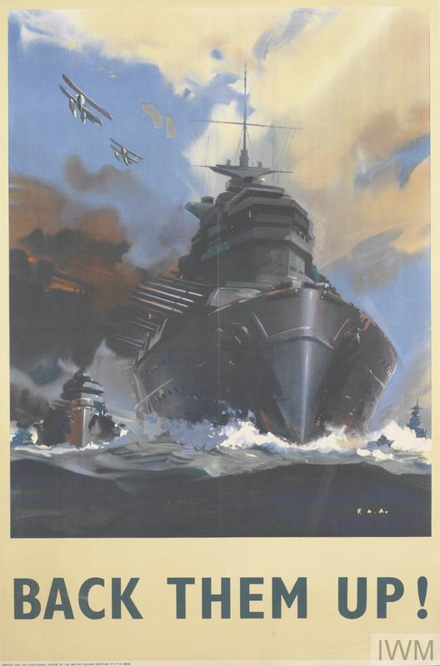
Propaganda Poster, Her Majesty’s Stationary Office, Ministry of Information, 1940. Source: Imperial War Museum, Art.IWM PST14874.

Task 1. Introduction

In groups, discuss briefly why military doctors in the Royal Navy might have shamed psychiatric patients and feminised them for their apparent lack of mental fortitude and lack of emotional self-control.

Answer the following questions:

- Why might men have been worried that that nervous breakdown would make them appear unmanly?

- How were wounded men expected to respond to pain in ships?

- In what ways might wounded men have found it difficult to follow idealised models of ‘heroic’ masculinity?
Task. 2. Fear and Mental Health: Balancing the Needs of Patients and the Ship under Enemy Attack.
In groups, read this extract from a memoir written by a ship’s doctor, who had to single-handedly treat the casualties of a series of attacks on his ship in 1942.

Document 1.

‘It was difficult for wounded and helpless men not to feel trapped during an attack and this panic feeling amongst these badly shocked men manifested itself by shouts and screams on the part of some of them especially the unfortunate boy with the broken back. I had the distasteful job of having to speak roughly to this boy to try to make him control himself. He stared back at me in dumb misery and I felt a brute as I climbed the ladder on to the upper deck, knowing that he could never do that any more. But panic was contagious and had to be controlled and the other wounded were complaining about him. I assured them that we would not leave them if the ship were in danger of sinking.’

(R. Ransome Wallis, Two Red Stripes: A Naval Surgeon at War (London: Ian Allen, 1973), pp.98-99).

Answer the following questions:

- What does this account tell historians about the challenges faced by ship’s doctors in giving emergency medical treatment to injured sailors? Why does the ship’s doctor feel unable to treat the frightened patient with a broken back sympathetically?

- How does this make the doctor feel? How far do you think he might be struggling with his own mental health here?

- How useful do you think this account is for historians studying the impact of fear on wartime mental health at sea?

Task 3. Diagnosing and Treating Mental Illness in Ships at Sea during the Second World War.

In groups, imagine you are a wartime naval doctor and a sailor has told you he is feeling very depressed and anxious, and is generally struggling with his mental health. Answer the following questions:

- What information would you need to know in order to diagnose whether he is simply worn out or suffering from a more serious medical problem?

- What questions would you ask the patient in order to decide how to treat him?

- How would you treat him?
Task 4. Medical Racism: Assessing the psychological effects of serving in the Tropics.
In groups, read these two extracts from official medical reports about the psychological illness known as ‘tropical neurosis’, a condition which was thought to affect the mental health of white British sailors working in tropical climates. *Please note that these extracts contain racist language*

Document 3.

‘Neurotic symptoms are commoner in the Tropics than at home’ … ‘One must not assume that hot climate is the sole cause of this picture… Service factors such as boredom, isolation, lack of amenities including beer and familiar diet, home worries – financial or marital – all these occur and may outweigh the hazards of enemy action. Add the stresses and strains of disordered sleep, fatigue, bodily discomfort (perpetual sweating, skin irritations, diarrhoea, flies); and also the constant association with coloured folk and a growing intolerance of their inexplicable habits.’

[‘Problems Of Naval Warfare Under Climatic Extremes: Part III. Lecture II, The British Medical Journal, Aug. 18, 1945]

Document 4.

‘In general it may be said that the threshold for breakdown on tropical service is much lower. The lower grade intelligence finds adaptation difficult; the temperamentally unstable reacts excessively and becomes a sick man; the man who had had previous nervous symptoms relapses; even the stable man with personal problems with which he has been able to deal, or previous stress of action that he has met without symptom, develops anxiety reactions after an uneventful term in the tropics. The dreamy escapist finds his retreat cut off, and succumbs to a depressive state. Sexual problems bulk much larger in the absence of other elements of life.’

[‘The Psychiatric Aspects of Tropical Service in the Navy’, by Surgeon Lieutenant Commander K. Cameron, 1945, The National Archives]

Answer the following questions:

- What do these medical reports identify as key causes of ‘tropical neurosis’ or mental breakdown whilst serving in the tropics?

- Who does this report identify as most likely to suffer from this condition, and why?

- How far do these reports agree that heat and humidity are the most significant causes of psychological illness in the tropics?

- In what ways do these reports suggest that factors of ‘race’ contribute to the white British sailor’s mental illness in the tropics?

- As historians, how should we handle racist language in historical documents like these?

- Thinking about what you have learnt today and what we discussed in the last session, reflect on the ways in which wartime medicine reinforced ideas about ‘racial’ differences. When archives/historical documents are racist, what can historians do to better understand the experience of patients of colour?

Task 5. Stresses of Service life at Sea as Causes of Poor Mental Health Among Sailors

In groups, fill in the boxes to show what you think the top three examples of stress factors in each area might be (eg. perhaps ‘bombs from enemy aircraft’ for ‘Enemy Action’).

Stress Factor: Domestic Difficulties
(35.6% of cases invalided out of Navy in 1942)

-
-
-

Stress Factor: Enemy Action
(29% of cases invalided out of Navy in 1942)

-
-
-

Stress Factor: Conditions of Service at Sea
(22.6% of cases invalided out of Navy in 1942)

-
-
-

Further activities to do at home
(if you want to strengthen your knowledge and expertise on the topic, and practice your skills of analysis as a historian – not compulsory!)

Task 6. Analysing Patient Experiences of Mental Breakdown

Read this extract from an interview with George Alder, a sailor who had served in many sea battles since the start of the war in 1939. Alder suffered a severe nervous breakdown after his ship came under repeated heavy attacks from enemy aircraft in the Mediterranean in 1941, and was sent to the 64th General Hospital in Alexandria, Egypt.

Alternatively, if you want to listen to this interview for yourself, follow this link. You will need to click on ‘Reel 3’ and start the interview 7 mins, 5 seconds in. https://www.iwm.org.uk/collections/item/object/80010452

Document 5. (Transcript of Interview)

‘On the way home from Souda Bay, I had what is commonly called a nervous breakdown, due to the continual bombardment of bombing. In other words, the slang expression was, you were ‘bomb happy’. In other words, it was a nervous condition, it was a nervous breakdown. And I was discharged to the 64th General Hospital in Alexandria, where I went into the mental ward with some very disturbing mental cases, for about ten days.
[INTERVIEWER: What symptoms do you have when you’re bomb happy?] Erm, it affects you in different ways. In my case, I was violently… I was violently sick all the time, vomiting, and it, erm, as you know, after that and your stomach is empty, this becomes an extremely painful and distressing condition. And, erm, you see all sorts of funny things happening to you.
[INTERVIEWER: What sort of things did you see?] Well the, although you were then in positively safe conditions, you think the next bomb you hear is a bomb that’s hit you. And the hospital ward there had some extremely distressing mental cases, Australian soldiers, several of them, they were very distressed. There was only two who were so badly mentally disturbed that you could say they were perhaps, not dangerous, but had to be carefully…
[INTERVIEWER: How were you treated, when you became bomb happy? Were you treated sympathetically?] Oh yes. In the hospital, the 64th General Hospital, very, very, the doctors were very sympathetic there. Naval doctors and civilian doctors.’

[The interview was conducted by an interviewer from the Imperial War Museum in 1989. George Thomas Cook Alder,
Ref: 10674, Reel 3, Imperial War Museum].

Answer the following questions:

- What does he believe caused his mental illness and what effects did it have on him?

- What does he mean by the phrase ‘bomb happy’?

- What does he think about his treatment in hospital?

- If you were the interviewer, what questions would you have asked this sailor about his illness and experience in hospital? What might you have to be sensitive towards? Is there anything that would be inappropriate to ask him?

- How useful do you think this extract is for historians? What are the strengths and limitations of this interview?

