Nursing and Caring around the World
Women in medical work during the Second World War
Dr Frances Houghton and Dr Laure Humbert, University of Manchester
Worksheet, East Manchester Academy
To learn more: colonialandtransnationalintimacies.com

Session One: What were nurses and ambulance drivers doing abroad during the Second World War? (1 February)

  - Introduction: Women in medical work during the Second World War

Task 1. Listen to Frances Houghton’s lecture and write down 3 facts that you found interesting:

-
-
-

  - Nursing and comforting men

Task. 2. In groups, examine the two photographs (document 1 and document 2). Describe what the nurses are doing? What can you see in the spaces in which they are working?

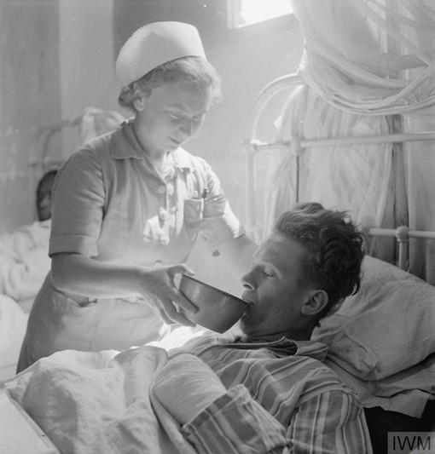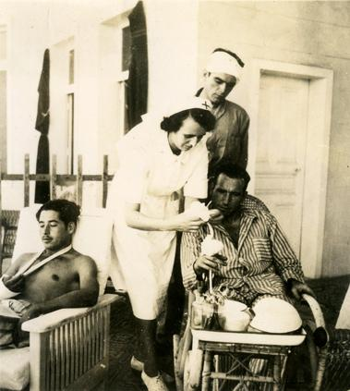Document 1. IWM, Ministry of Information, official collection, Cecil Beaton, IWM CBM 1006. [February – July 1942]. A Hadfield Spears Ambulance Unit nurse helps a patient to drink from a bowl on a ward in the general hospital. The patient is Corporal Carl de Wet, 1st South African anti-aircraft regiment. The sister is Nurse Cohen, a Jewish refugee from Lubeck in Poland. Document 2. Friends’ Library London, A77, Hadfield Spears collection, undated.

  - Working in the extreme environment of the desert war

Task 3. In groups, examine these photographs of nurses in the desert (document 3 and 4).
Which of these do you think nurses would have found the hardest? Why?

Once you’ve ticked your answer, imagine you’re a nurse in the desert during the war. Which of these would you personally find most challenging, and why? Are there any challenges NOT listed below that you think nurses and ambulance drivers might have faced?

☐ The cold
☐ Tiredness
☐ Homesickness
☐ Scorpions
☐ Air attacks
☐ Sandstorms
☐ Flies
☐ Lack of water
☐ Extreme temperatures

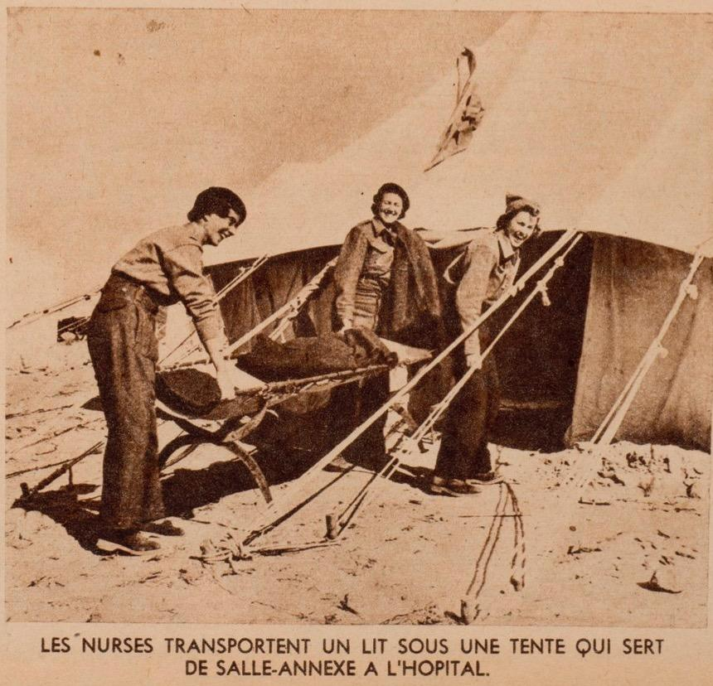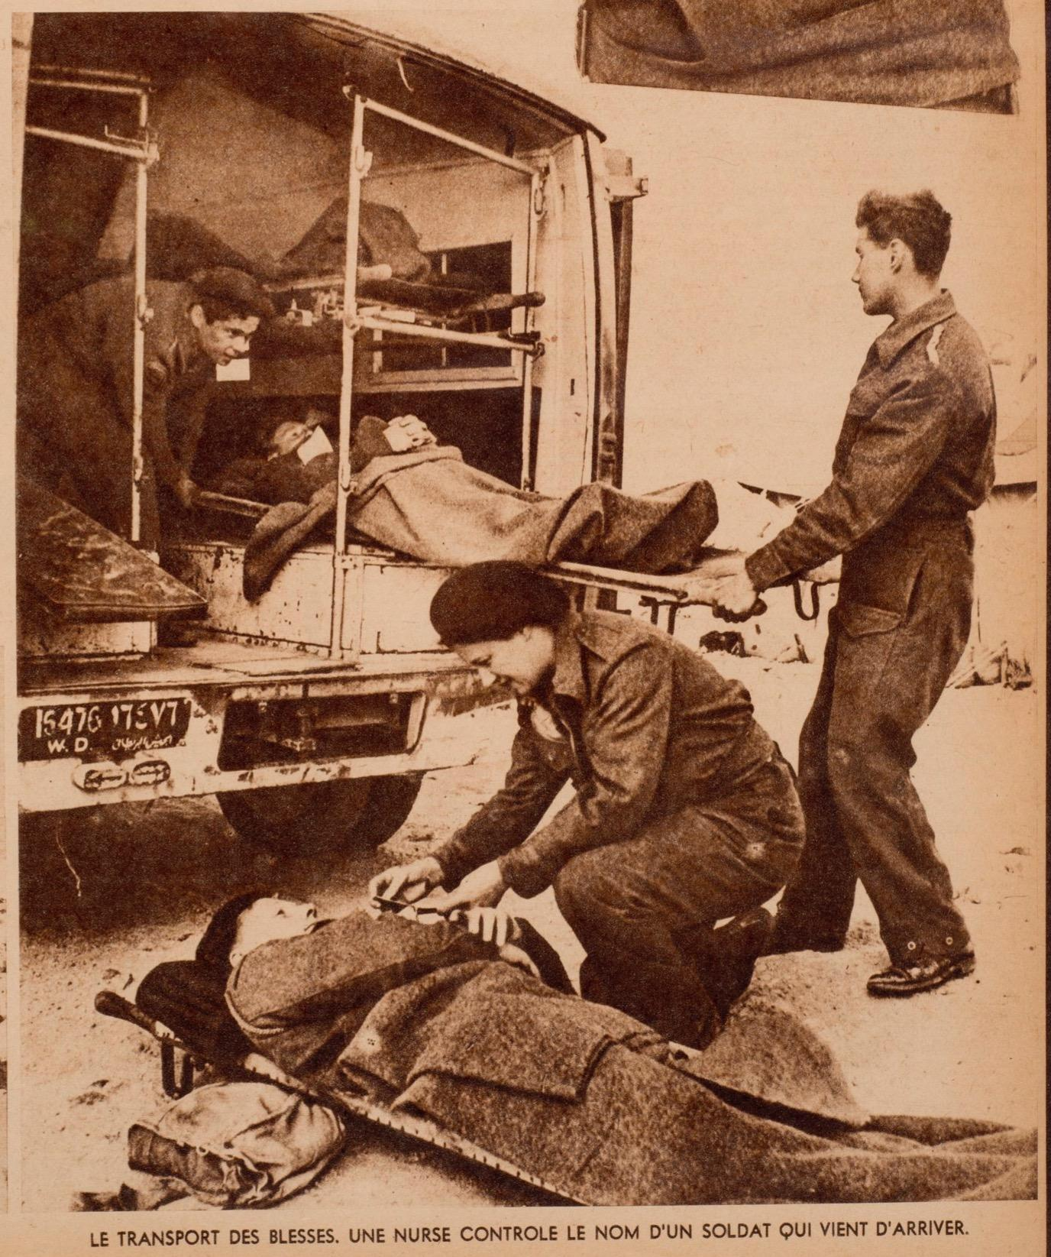
Document 3. ‘The nurses are transporting a bed under the tent which serves as an annex in hospital’, ‘Infirmières sur le front’, Images, No. 650, Le Caire (Egypte), 23 February 1942, p. 12.
Document 4. ‘The transport of wounded men. A nurse controlled the name of a soldier which just arrived’. ‘Infirmières sur le front’, Images, No. 650, Le Caire (Egypte), 23 February 1942, p. 13.

  - Experiencing a sandstorm (Josephine Pearce)

Task 4. Listen to the interview of Josephine Pearce, a British nurse working for the Free French, and answer the following questions:

- How did the nurses protect themselves from the sandstorm?
- Who wanted to shelter with them?
- What sort of clothes were the nurses wearing? Why does Josephine Peace say ‘we must have been a pretty horrible sight’?

Document 5. IWM, Extract of Josephine Pearce interview by Margaret Brooks, 1976, reel 12, 15’’ – 17’’55 (available: https://www.iwm.org.uk/collections/item/object/80000825)

  - Driving in the desert

Task 5. In group, examine these photographs (documents 6 and 7) and tick the answers you think are true.

Being an ambulance driver required:
☐ Being rich
☐ Physical Strength
☐ Being married
☐ Excellent driving skills
☐ Being brave
☐ Being a good mechanic
☐ Basic nursing skills
☐ Wearing a uniform
☐ Being outgoing
☐ Being British
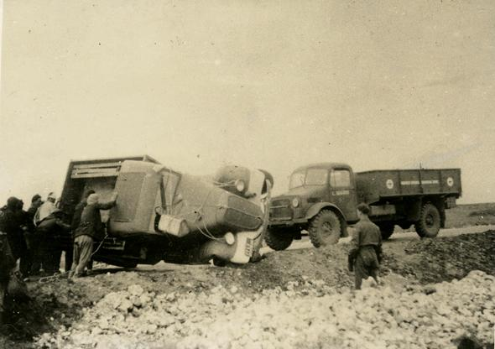
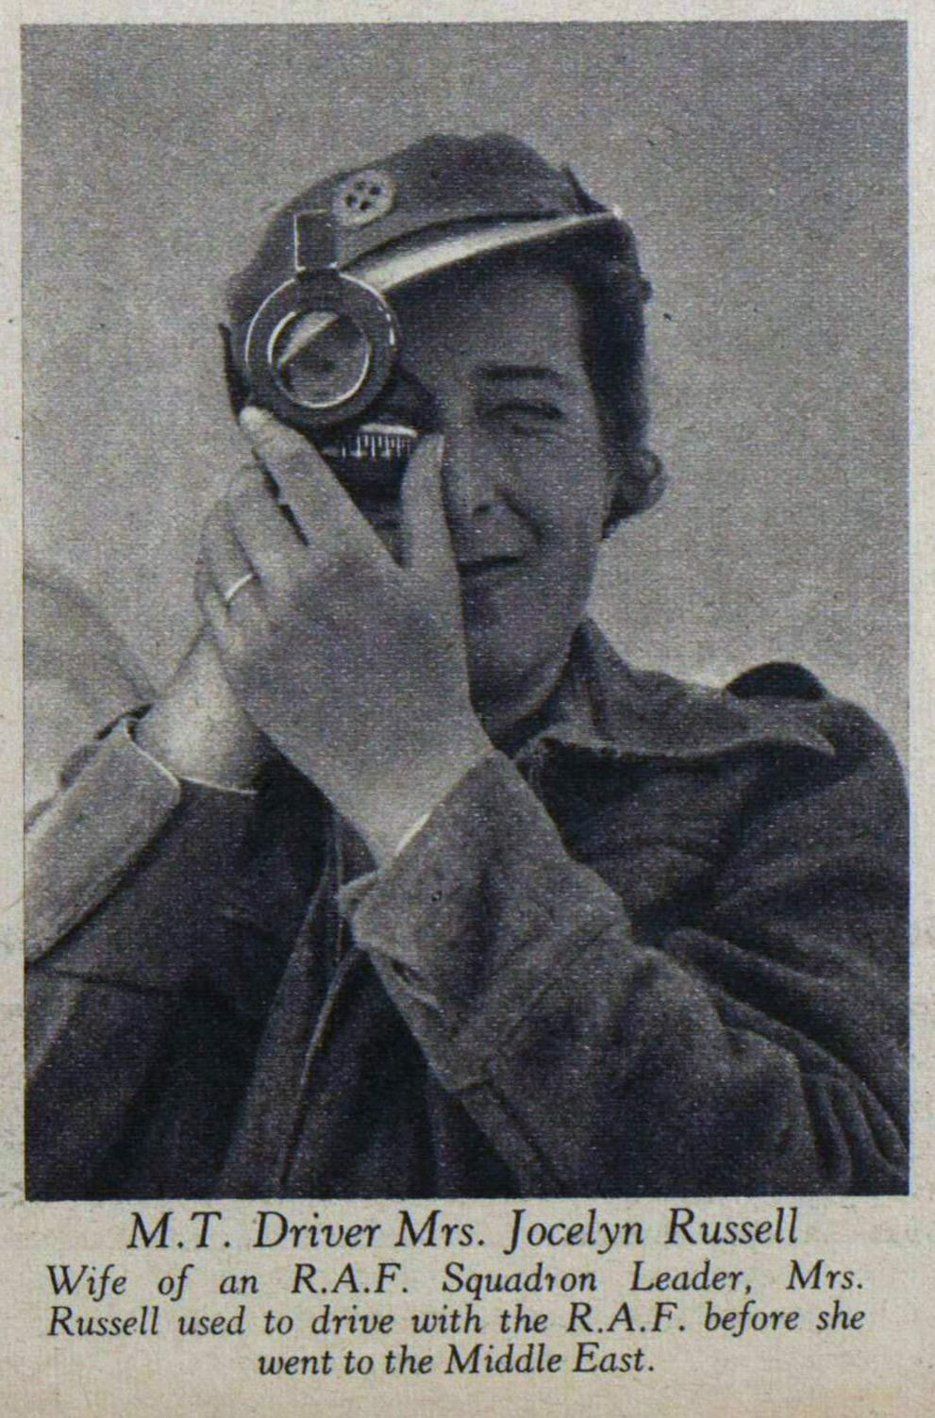
☐ Able to ‘rough it’ in the desert

Document 6. Friends’ Library London, A75, Hadfield Spears Mobile Hospital [undated].
Document 7. ‘Our Nurses in Tobruk’, Picture Post, 21 March 1942

Session Two. How did ambulance drivers and nurses feel near the front line? (8 February)

2.1 Introduction

Task 1. In group, reflect on what we have learnt last week and answer the following question:

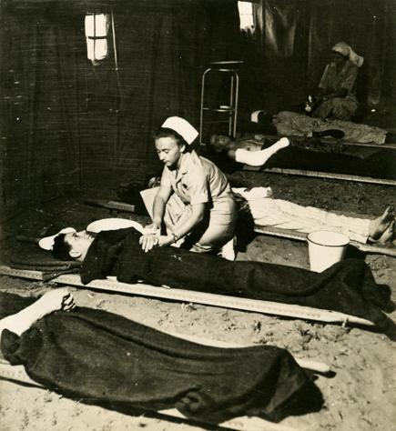

What might this nurse be feeling when attending this wounded man?

2.2 Seeing pain

Task 2. In group, read the extract of Rachel Millet’s story (document 8) and answer the following questions:
- Why were Rachel Millet and her colleagues praying for the death of seriously wounded men?
- Why did she think that amputation was the worst wound?
- How do you think that seeing pain made nurses and ambulance drivers feel?
- If there are any words you’re not sure about, please ask!

Document 8. Rachel Millet (Ambulance driver in El Alamein)

‘Above all I had to learn to cope with horrendous wounds without showing faintness or distress. Luckily I was so busy I had no time to think of myself. Bullets made a small entry wound and a large exit, often taking with them pieces of clothing or anything else that stood in their way. Shrapnel made terrible jagged wounds. Landmines shattered arms and legs, and often blinded as well. Some of the saddest cases were men who had lost their eyes and hands through stepping on a mine. We prayed they would die, but they seldom did. The worst wounds to dress were amputation, often double. They took ages and caused agonising pain however careful one was. We gave morphia before we did them but it did not seem to help much’.
Rachel Millet Spearette. A memoir of the Hadfield-Spears Ambulance Unit (London: Fern House, 1998), p. 18.

2.3 Facing danger and death

Task 3. In group, read the extract of the article in Picture Post (document 9) and answer the questions.
What dangers did women face in Tobruk?
Were these dangers the same as those faced by male soldiers?
How far do you think the presence of female nurses and ambulance drivers help boost the morale of their patient-soldiers?

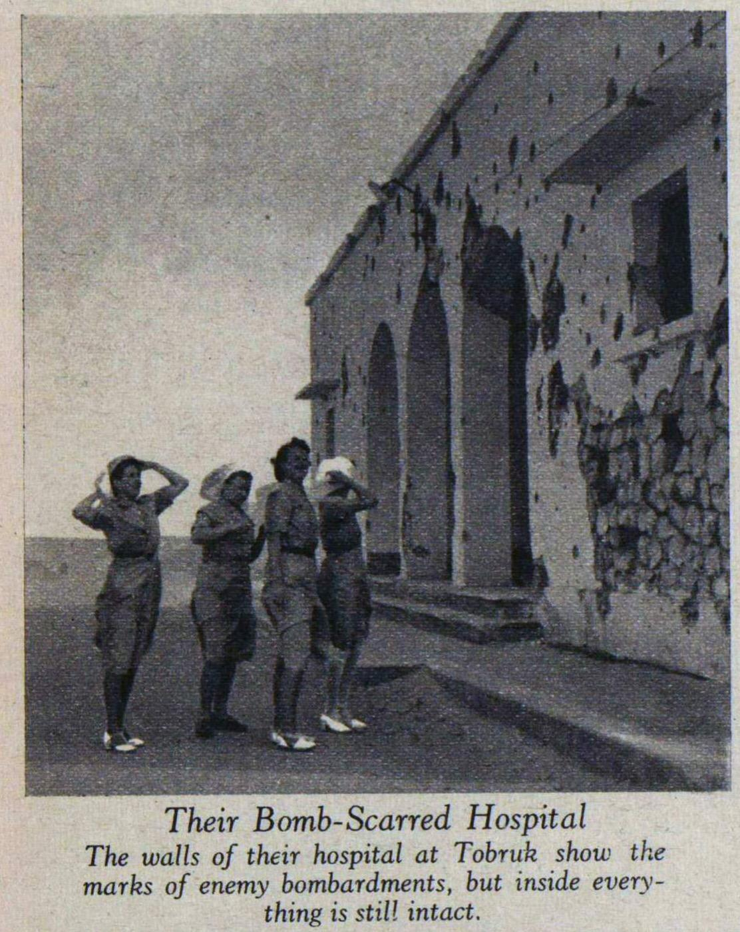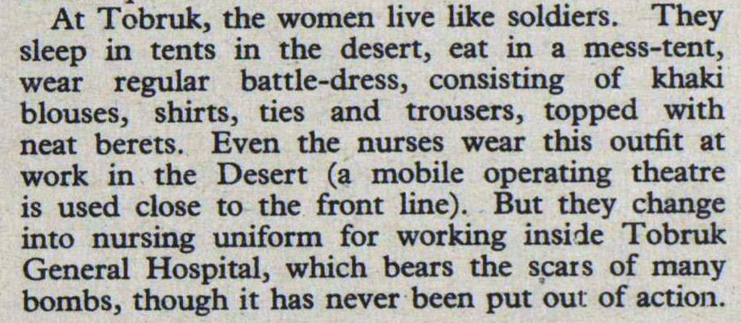

Document 9. Extract from ‘Our Nurses in Tobruk’, Picture Post, 21 March 1942.

2.4 Improving their medical and clinical skills

Task 4. In groups, tick the correct answers:

Why were nurses required to learn new skills during the war? Which do you think the most important reason is?

☐ because they were told to
☐ because of the development of new ways of treating people, like blood transfusion
☐ because they were bored
☐ because of the development of new medicine, including penicillin
☐ because it was fun
☐ because of working in different environment
☐ because their work with doctors and nurses from different parts of the world

  - researching the history of medical women at war

Task 5. In group, pick one of the nurses/ambulance drivers below. Design 4 questions you’d like to ask this nurse/ambulance drivers if they were still alive today. Is there anything you might need to be sensitive towards in your interview? What might these authors be shy to talk about? Why?

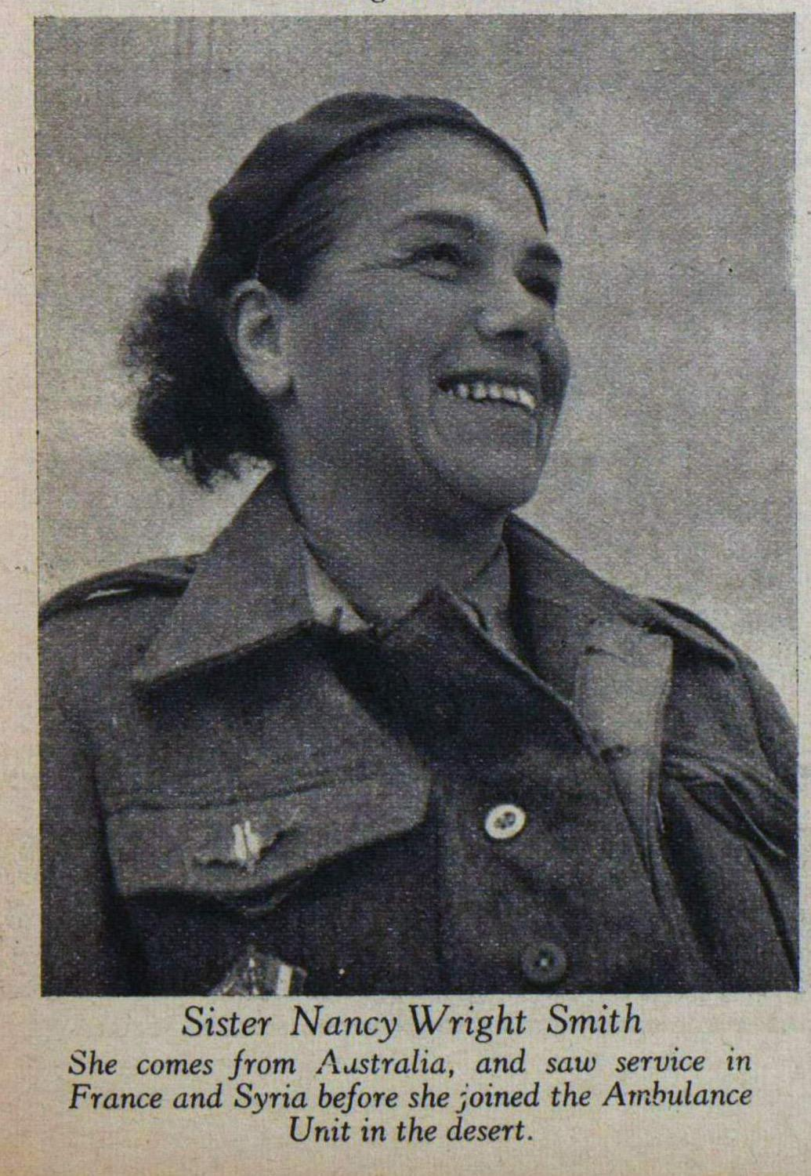
1.

2.

3.

4.
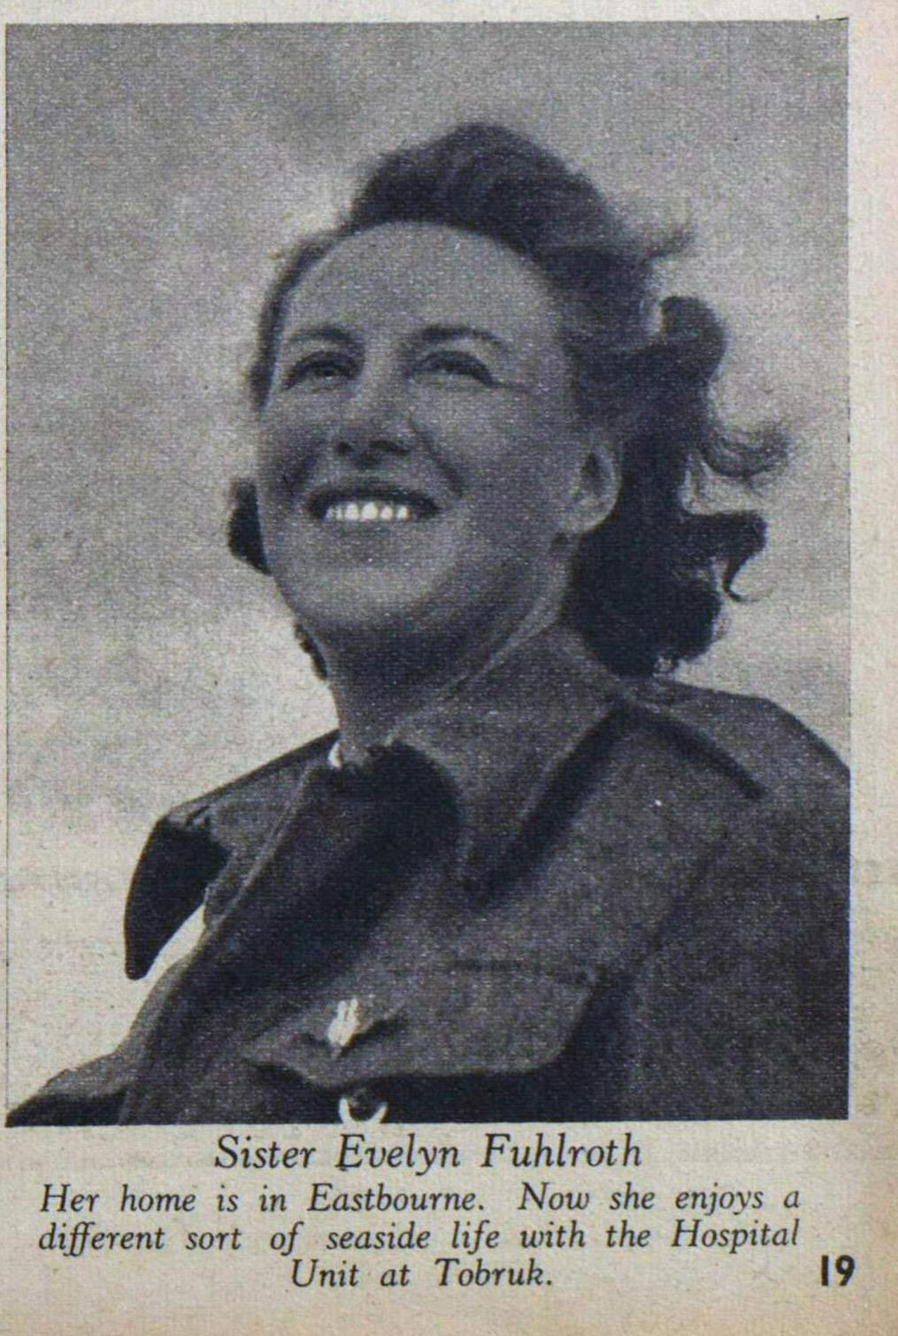
1.

2.

3.

4.
1.

2.

3.

4.

Session 3. Coming Home after the War (25 February)

3.1 Introduction: Imagining ‘home’ during the war

Task 1. Listen to the lecture and answer these two questions:

What might this nurse be looking forward when she comes home after the war?

What might she be worried about?

Task 2. In group, tick the answer you think best applies to the question:

Nurses and ambulance drivers might not have told their family about the most difficult aspects of their work because:

☐ government’s censorship
☐ self-censorship (they were worried about upsetting their family)
☐ memory loss (they could/did not want to remember it all)
☐ they could not be bothered

3.2 Writing a postcard

Task 3. In group, imagine you are a nurse abroad and write a postcard to either your mother or your fiancé talking about your experiences. You might decide to make a drawing as well as writing. The best postcards will be posted on our website (www.colonialandtransnationalintimacies.com).

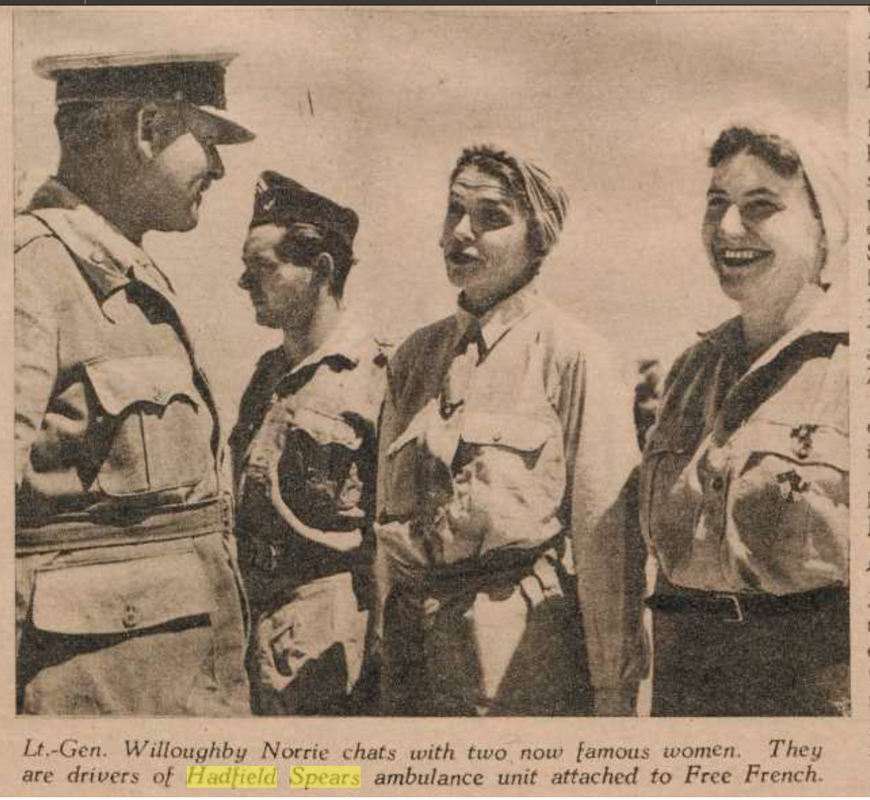
Crusader , 22 June 1942.

